DBMS Assignment # 1

# Submitted to:

* Sir Samyan Qayyum Wahla

# Submitted by:

* 2016-CS-178

# Department of Computer Science and Engineering

# UET Lahore

**Date:** 08-Oct-2018



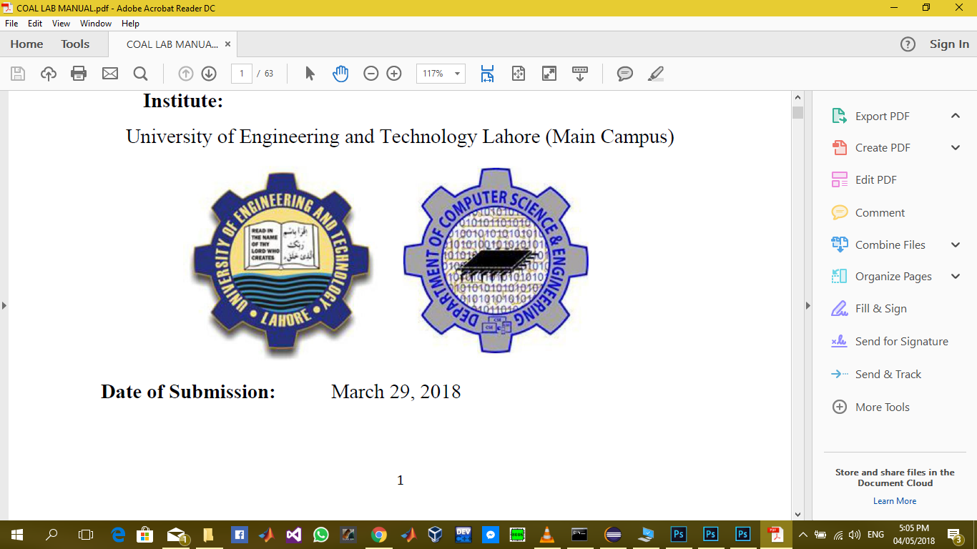

Table of Contents

Submitted to: 1

Submitted by: 1

Department of Computer Science and Engineering 1

UET Lahore 1

Introduction 3

Static Websites 3

Dynamic Websites 3

Dynamic Websites 3

Facebook.com 3

Youtube.com 3

Google.com 3

Quora.com 4

Linkedin.com 4

Wordpress.com 4

Netflix.com 4

Microsoft.com 4

Wikipedia.com 5

Amazon.com 5

Instagram.com 5

Stack overflow.com 5

# Introduction

There are two types of websites in terms of data.

## Static Websites

Static websites contain only static content. There is no considerable user interface in static webpage. No data from the end user is stored. A fixed amount of content is showed every time the page is loaded.

## Dynamic Websites

Websites on which considerable amount of time is spent on user interaction and displaying the user related information. There is need to store data in a proper comprehensive way. So that there is need for creation of database.

# Dynamic Websites

## Facebook.com

|  |  |
| --- | --- |
| Database Name | MySQL |
| Developer | MySQL AB |
| Written in | C, C++ |
| License | GPLv2 |
| Type | RDBMS |
| Platform | Linux, Solaris, macOS, Windows, FreeBSD |
| Release Date | May 23, 1995 |

## Youtube.com

|  |  |
| --- | --- |
| Database Name | MySQL |
| Developer | MySQL AB |
| Written in | C, C++ |
| License | GPLv2 |
| Type | RDBMS |
| Platform | Linux, Solaris, macOS, Windows, FreeBSD |
| Release Date | May 23, 1995 |

## Google.com

|  |  |
| --- | --- |
| Database Name | Google Bigtable |
| Developer | Google Incorporate |
| Written in | C Language |
| License | Closed Source |
| Type | Cloud Storage |
| Platform | Google Cloud Platform |
| Release Date | February 2005 |

## Quora.com

|  |  |
| --- | --- |
| Database Name | MySql |
| Developer | Adam D Angelo |
| Written in | Python, C++ |
| License | TOS |
| Type | Data structure store, key-value database |
| Platform | Cross Platform |
| Release Date | June, 2009 |

## Linkedin.com

|  |  |
| --- | --- |
| Database Name | Project Voldemort |
| Developer | LinkedIn |
| Written in | Java |
| License | Apache License |
| Type | Distributed Data Store |
| Platform | Cloud Storage |
| Release Date | 2009 |

## Wordpress.com

|  |  |
| --- | --- |
| Database Name | Mongo DB |
| Developer | Mongo DB Incorporate |
| Written in | C, C++, Java |
| License | Various |
| Type | Document Oriented Database |
| Platform | Windows, Linux, Mac, Solaris, Free BSD |
| Release Date | February 11, 2009 |

## Netflix.com

|  |  |
| --- | --- |
| Database Name | MySQL, PostgreSQL, Cassandra, Oracle |
| Developer | Reed Hasting, Marc Randolph |
| Written in | Python,Java |
| License | Various |
| Type | Document Oriented Database |
| Platform | Windows, Mac OS, Mobile Phones |
| Release Date | 2007 |

## Microsoft.com

|  |  |
| --- | --- |
| Database Name | Microsoft SQL Server |
| Developer | Microsoft Incorporate |
| Written in | C, C++ |
| License | Closed Source |
| Type | Relational Database Management System |
| Platform | Microsoft Windows |
| Release Date | April 24, 1989 |

## Wikipedia.com

|  |  |
| --- | --- |
| Database Name | MariaDB |
| Developer | MariaDB Corporation AB |
| Written in | C, C++, Perl, Bash |
| License | GPLv2, LGPLv2.1 |
| Type | Relational Database Management System |
| Platform | Windows, Mac, Linux |
| Release Date | October 29, 2009 |

## Amazon.com

|  |  |
| --- | --- |
| Database Name | Oracle Database |
| Developer | Oracle Corporation |
| Written in | Assembly Language, C, C++ |
| License | Closed Source |
| Type | Multi-model database |
| Platform | Windows, Mac, Linux |
| Release Date | February 18, 2018 |

## Instagram.com

|  |  |
| --- | --- |
| Database Name | PostGreSQL |
| Developer | PostGreSQL Global Development Group |
| Written in | C |
| License | Open Source |
| Type | ORDBMS |
| Platform | Windows, Unix-like OS |
| Release Date | July 8, 1996 |

## Stack overflow.com

|  |  |
| --- | --- |
| Database Name | Microsoft SQL Server. |
| Developer | Jeff Atwood, Joel Spolsky. |
| Written in | C# |
| License | Open Source |
| Type | ASP .Net Framework |
| Platform | Cross Platform |
| Release Date | September 15, 2008 |